

Foundations of Programming

Assignment No. : 01
- PROBLEM STATEMENT:
Write a program in C to check whether a given year is a Leap Year

OBJECTIVE:

- To understand the use of conditional statements in C programming.
- To implement logical conditions for solving real-world problems.
- To develop problem-solving skills using decision control structures.

THEORY:
- Theory for conditional statements with syntax (if , if-else, if-else ladder) are used in C programming
- Theory for a Leap Year - year that contains 366 days instead of the usual 365 days.
Rules:
• A year is a leap year if it is divisible by 400, OR
• A year is a leap year if it is divisible by 4 but not divisible by 100.
- Algorithm
PLATFORM: Linux

ALGORITHM:

(1): Start
(2): Read year value as x
(3): Check if x%4==0 and x%100!=0 , if true print given year is leap year
(4): Else if x%400=0 , print year is leap year
(5): Else print year is not leap year
(6): End

FLOWCHART:
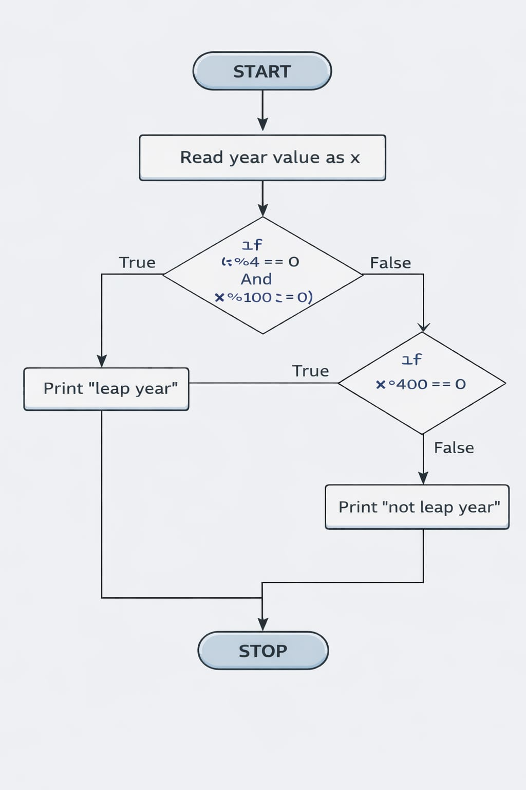

INPUT:

#include <stdio.h>
int main() {
int x;
printf("Enter a year: ");
scanf("%d", &x);

if (x % 400 == 0) {
printf("%d is a leap year.", x);
}

else if (x % 100 == 0) {
printf("%d is not a leap year.", x);
}

else if (x % 4 == 0) {
printf("%d is a leap year.", x);
}

else {
printf("%d is not a leap year.", x);
}

}

OUTPUT: Displays whether the entered year is a Leap Year or Not a Leap Year.
Enter a year: 2012
2012 is a leap year.

CONCLUSION: Thus, the program successfully checks whether a given year is a Leap Year using conditional statements in C.

FAQs:
- What is a leap year?
- Why is the year 1900 not a leap year but 2000 is?
- Which operators are used in this program?
- Difference between if and if–else statements.

